Wehsma Town Council Monthly Meeting to be held on Tuesday, 9th May 2023
at 7.30pm in the Committee Room, Wesham Community Centre.

AGENDA

APOLOGIES:

CODE OF CONDUCT AND STANDING ORDERS
Members are reminded of the standard of conduct they must adhere to during Town Council meetings.

DECLARATION OF INTERESTS:
Members are reminded that any direct or indirect pecuniary or other interests should be declared as required by the Council’s Code of Conduct for Members.

23/045 APPROVAL OF THE MINUTES OF THE COUNCIL MEETING HELD 21st March 2023
23/046 MATTERS ARISING – any item not covered by agenda or action list

- Parish Town Council Elections Spring 2023
- Mayor for 2023–24 & Mayor Making
- Co-option of Wesham councillors

23/046 POLICING ISSUES - none noted to review since 18th April 2023
- Crime Reports – police.org.uk website > area > PR4 3DR (WCC postcode)
- Policing Issues – to discuss any items raised by Councillors

23/047 PLANNING -
- Planning Applications -

23/0291- shop to flat, 34 Station Road, Wesham

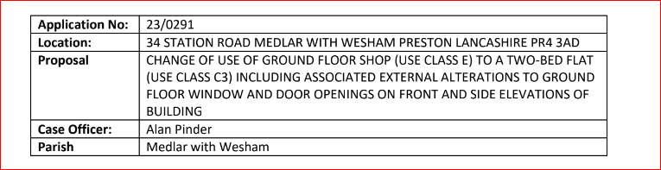

23/048 PLAYING FIELDS and OPEN SPACES -
- Open Spaces Contract - to discuss any issues raised by Councillors

Summer Bedding update?

- Fleetwood Road Playing Fields - to discussed any issues raised
Barrier proposal from Archforge - plan requested by TC
- Doorstep Green, Derby Road - to discussed any issues raised.
- Street Cleaning in Wesham
- Allotments
- Wesham Bowling Club

23/049 HIGHWAYS AND RAILWAYS – to discussed any issues raised

23/050 GOVERNANCE, FINANCE AND INSURANCE

Accounts payable and income received report –

WTC Monthly summary – April 2023

Freckleton Marsh Chq

Accident and Incident Reporting – none

- WTC/WCC equipment

23/051 EVENTS -
- Community Club Day Field Event -
23/052 HUMAN RESOURCES
- HR sub Committee – update?
- WCC Manager – LM
- Review of payrates – HR Sub-Committee recommendations ?

23/053 WESHAM COMMUNITY CENTRE
- Re-Boot to Tills - Updates
- Heating system repairs WCC – Updates

23/054 OTHER
- Website
- Actions

DATE OF NEXT WTC monthly meetings: –
18th April 2023
9th May 2023
13th June 2023
20th June 2023

WTC Additional Meetings
Date | Meeting
9th May | WTC Monthly Meeting
13th June 2023 | Mayor making ?
20th June2023 | WTC Monthly Meeting
TBA | Wesham Bowling Club 2nd meeting ?
TBA | KJFC SLA 2nd meeting

Angela Hunter Date: 3rd May 2023

